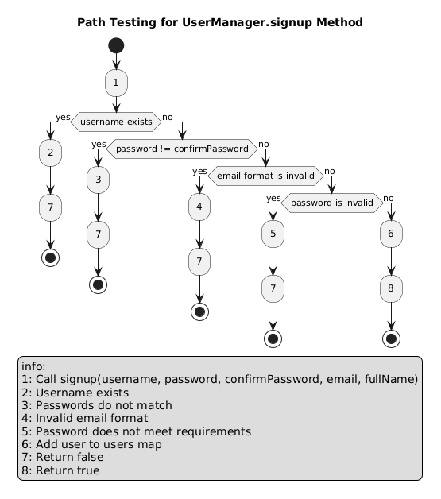

**Identify Prime Paths**

Prime paths are the longest paths in the control flow graph that do not repeat any nodes except possibly the first and last. For the signup method, the prime paths are:

* **Path 1**: [1, 2, 7] or 1 → 2 → 7
* **Path 2**: [1, 3, 7] or 1 → 3 → 7
* **Path 3**: [1, 4, 7] or 1 → 4 → 7
* **Path 4**: [1, 5, 7] or 1 → 5 → 7
* **Path 5**: [1, 2, 3, 4, 5, 6, 8] or 1 → 2 → 3 → 4 → 5 → 6 → 8

**Identify Actual Paths**

Actual paths for testing would be the specific paths through the method for various test cases:

* **Path A**: 1 → 2 → 7 (Username exists)
* **Path B**: 1 → 3 → 7 (Passwords do not match)
* **Path C**: 1 → 4 → 7 (Invalid email format)
* **Path D**: 1 → 5 → 7 (Invalid password)
* **Path E**: 1 → 2 → 3 → 4 → 5 → 6 → 8 (Successful signup)

**Path Coverage**

1. **Path 1**: 1 -> 2 -> 7
   * Path Length: 3
   * Simple Path: Yes
   * Prime Path: Yes
   * Complete Round Trip Coverage: Not applicable
   * Simple Round Trip Coverage: Not applicable
2. **Path 2**: 1 -> 3 -> 7
   * Path Length: 3
   * Simple Path: Yes
   * Prime Path: Yes
   * Complete Round Trip Coverage: Not applicable
   * Simple Round Trip Coverage: Not applicable
3. **Path 3**: 1 -> 4 -> 7
   * Path Length: 3
   * Simple Path: Yes
   * Prime Path: Yes
   * Complete Round Trip Coverage: Not applicable
   * Simple Round Trip Coverage: Not applicable
4. **Path 4**: 1 -> 5 -> 7
   * Path Length: 3
   * Simple Path: Yes
   * Prime Path: Yes
   * Complete Round Trip Coverage: Not applicable
   * Simple Round Trip Coverage: Not applicable
5. **Path 5**: 1 -> 6 -> 8
   * Path Length: 3
   * Simple Path: Yes
   * Prime Path: Yes
   * Complete Round Trip Coverage: Not applicable
   * Simple Round Trip Coverage: Not applicable

Definitions:

- Path: A sequence of instructions or decisions taken in the program.

- Path Length: The number of nodes (instructions or decisions) in the path.

- Sub-path: A part of a path that might be executed.

- Complete Path Coverage: Ensuring all possible paths are tested.

- Simple Paths: Paths with no loops.

- Prime Paths Coverage: Paths that are not sub-paths of any other path.

- Complete Round Trip Coverage: Covering all loops in the program.

- Simple Round Trip Coverage: Covering all simple cycles in the program.